**Spring MVC**

* **Implement AbstractController in StudentController. create a mapping index.html for it and render index.jsp view from it which displays messages "Hello from index.jsp"**

***Web.xml***

*<?***xml version="1.0" encoding="UTF-8"***?>*<**web-app xmlns="http://xmlns.jcp.org/xml/ns/javaee"  
 xmlns:xsi="http://www.w3.org/2001/XMLSchema-instance"  
 xsi:schemaLocation="http://xmlns.jcp.org/xml/ns/javaee http://xmlns.jcp.org/xml/ns/javaee/web-app_3_1.xsd"  
 version="3.1"**>  
 <**servlet**>  
 <**servlet-name**>dispatcher</**servlet-name**>  
 <**servlet-class**>org.springframework.web.servlet.DispatcherServlet</**servlet-class**>  
 <**load-on-startup**>1</**load-on-startup**>  
 </**servlet**>  
  
 <**servlet-mapping**>  
 <**servlet-name**>dispatcher</**servlet-name**>  
 <**url-pattern**>/</**url-pattern**>  
 </**servlet-mapping**>  
</**web-app**>

**Dispatcher-servlet.xml**

*<?***xml version="1.0" encoding="UTF-8"***?>*<**beans xmlns="http://www.springframework.org/schema/beans"  
 xmlns:context="http://www.springframework.org/schema/context"  
 xmlns:xsi="http://www.w3.org/2001/XMLSchema-instance"  
 xmlns:mvc="http://www.springframework.org/schema/mvc"  
 xsi:schemaLocation="http://www.springframework.org/schema/beans  
 http://www.springframework.org/schema/beans/spring-beans.xsd  
 http://www.springframework.org/schema/context  
 http://www.springframework.org/schema/context/spring-context.xsd  
 http://www.springframework.org/schema/mvc  
 http://www.springframework.org/schema/mvc/spring-mvc.xsd"**>  
  
 <**bean id="HandlerMapping" class="org.springframework.web.servlet.handler.BeanNameUrlHandlerMapping"**></**bean**>  
<**bean name="/index.html" class="com.controller.StudentController"**></**bean**>  
 <**bean id="viewResolver" class="org.springframework.web.servlet.view.InternalResourceViewResolver"**>  
 <**property name="prefix"** >  
 <**value**>/WEB-INF/view/jsp/</**value**>  
 </**property**>  
 <**property name="suffix"**>  
 <**value**>.jsp</**value**>  
 </**property**>  
 </**bean**>  
  
<**mvc:annotation-driven**></**mvc:annotation-driven**>  
  
</**beans**>

**StudentController**

**package** com.controller;  
  
**import** org.springframework.web.bind.annotation.RequestMapping;  
**import** org.springframework.web.servlet.ModelAndView;  
**import** org.springframework.web.servlet.mvc.AbstractController;  
  
**import** javax.servlet.http.HttpServletRequest;  
**import** javax.servlet.http.HttpServletResponse;  
**public class** StudentController **extends** AbstractController{  
  
 @Override  
 **protected** ModelAndView handleRequestInternal(HttpServletRequest httpServletRequest, HttpServletResponse httpServletResponse) **throws** Exception {  
  
 ModelAndView modelAndView = **new** ModelAndView(**"index"**);  
 modelAndView.addObject(**"message"**,**"Hello from index.jsp"**);  
 **return** modelAndView;  
 }  
}

**index.jsp**

<**html**>  
<**head**>  
 <**title**>Title</**title**>  
</**head**>  
<**body**>  
**${**message**}**</**body**>  
</**html**>

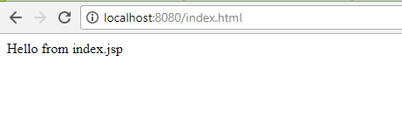

* **Now remove AbstractController and useMultiActionController for StudentController which contains 2 actions one action renders a jsp view and another action uses HttpServletResponse to show the output on the Web browser.**

MultiActionController is not working as it is deprecated

* **Use annotation in StudentController to define a default action index which renders a jsp page.**

**Web.xml**

*<?***xml version="1.0" encoding="UTF-8"***?>*<**beans xmlns="http://www.springframework.org/schema/beans"  
 xmlns:context="http://www.springframework.org/schema/context"  
 xmlns:xsi="http://www.w3.org/2001/XMLSchema-instance"  
 xmlns:mvc="http://www.springframework.org/schema/mvc"  
 xsi:schemaLocation="http://www.springframework.org/schema/beans  
 http://www.springframework.org/schema/beans/spring-beans.xsd  
 http://www.springframework.org/schema/context  
 http://www.springframework.org/schema/context/spring-context.xsd  
 http://www.springframework.org/schema/mvc  
 http://www.springframework.org/schema/mvc/spring-mvc.xsd"**>  
<**context:component-scan base-package="com.controller"**></**context:component-scan**>  
<**bean id="viewResolver" class="org.springframework.web.servlet.view.InternalResourceViewResolver"**>  
 <**property name="prefix"** >  
 <**value**>/WEB-INF/view/jsp/</**value**>  
 </**property**>  
 <**property name="suffix"**>  
 <**value**>.jsp</**value**>  
 </**property**>  
 </**bean**>  
  
<**mvc:annotation-driven**></**mvc:annotation-driven**>  
  
</**beans**>

**StudentController**

@Controller  
**public class** StudentController{  
 @RequestMapping(method = RequestMethod.***GET***)  
 **public** ModelAndView callIndexJsp(){  
  
 ModelAndView modelAndView = **new** ModelAndView(**"index"**);  
 modelAndView.addObject(**"message"**,**"Hello from index.jsp"**);  
 **return** modelAndView;  
 }  
  
  
}

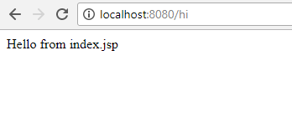

* **Create one more annotation based action hello inside the StudentController which and use @ResponseBody annotation from it to display Hello world.**

@Controller  
**public class** StudentController{  
 @RequestMapping(method = RequestMethod.***GET***)  
 **public** ModelAndView callIndexJsp(){  
  
 ModelAndView modelAndView = **new** ModelAndView(**"index"**);  
 modelAndView.addObject(**"message"**,**"Hello from index.jsp"**);  
 **return** modelAndView;  
 }  
  
 @RequestMapping(**"/index"**)  
 @ResponseBody  
 String hello(){  
 **return "Hello World"**;  
 }  
  
  
}

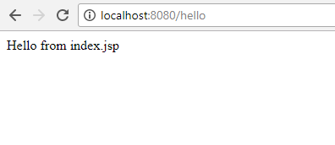

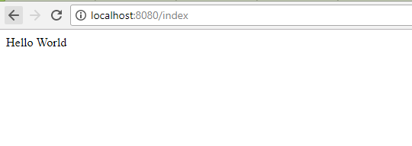

* **Create one more action which sends Model HelloWorld to the jsp file.**

@Controller  
**public class** StudentController{  
 @RequestMapping(**"/index"**)  
 **public** ModelAndView callIndexJsp(){  
  
 ModelAndView modelAndView = **new** ModelAndView(**"index"**);  
 modelAndView.addObject(**"message"**,**"Hello World"**);  
 **return** modelAndView;  
 }  
  
  
}

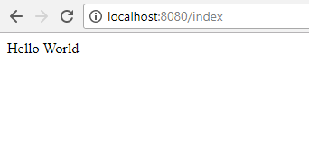

* **Use @PathVariable annotation to access firstname and lastname in an action inside StudentController place both the parameters in different arguments and access them.**

@Controller  
**public class** StudentController{  
   
 @RequestMapping(value = **"/{fname}/{lname}"** )  
 **public** ModelAndView submit(@PathVariable(**"fname"**)String fname,@PathVariable(**"lname"**) String lname){  
 ModelAndView modelAndView = **new** ModelAndView(**"index"**);  
 modelAndView.addObject(**"message"**,**"First Name: "**+fname+**"\n Last Name: "**+lname);  
 **return** modelAndView;  
  
 }  
}

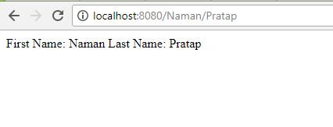

* **Now place both the arguments inside a Map and access the Map instead.(Hint : check the slide for @PathVariable action returnCountryAndState  shows how to do it with map)**

@RequestMapping(value = **"/index/{firstname}/{lastname}"** )  
**public** ModelAndView submit(@PathVariable Map<String,String> name){  
 String fname = name.get(**"firstname"**);  
 String lname = name.get(**"lastname"**);  
 ModelAndView modelAndView = **new** ModelAndView(**"index"**);  
 modelAndView.addObject(**"message"**,**"First Name: "**+fname+**" Last Name: "**+lname);  
 **return** modelAndView;  
  
}

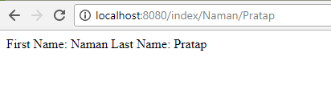

* **Use @RequestParam annotation to access the firstname and lastname in formData action of StudentController.**

**Form.jsp**

<**html**>  
<**head**>  
 <**title**>Title</**title**>  
</**head**>  
<**body**>  
<**form action="/submitForm" method="post"**>  
 <**input type="text" name="firstName" placeholder="First Name"**><**br**/><**br**/>  
 <**input type="text" name="lastName" placeholder="Last Name"**><**br**/><**br**/>  
 <**input type="submit" value="Submit"**>  
</**form**>  
</**body**>  
</**html**>

**StudentController.java**

@Controller  
**public class** StudentController{  
 @RequestMapping(**"/form"**)  
 **public** ModelAndView callIndexJsp(){  
  
 ModelAndView modelAndView = **new** ModelAndView(**"form"**);  
 **return** modelAndView;  
 }

@RequestMapping(value = **"/submitForm"** ,method = RequestMethod.***POST***)  
 **public** ModelAndView submit(@RequestParam(**"firstName"**)String fname, @RequestParam(**"lastName"**) String lname){  
 ModelAndView modelAndView = **new** ModelAndView(**"index"**);  
 modelAndView.addObject(**"message"**,**"First Name: "**+fname+**"\nLast Name: "**+lname);  
 **return** modelAndView;  
  
 }  
  
 }

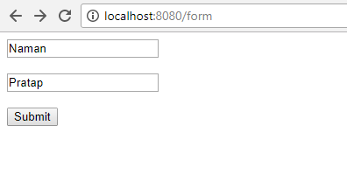

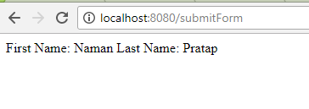

* **Create a StudentCO and bind firstname and lastname with instance variable of StudentCO.**

**StudentCO.java**

**package** com.controller;  
  
**public class** StudentCO {  
 String **firstName**;  
 String **lastName**;  
  
 **public** String getFirstName() {  
 **return firstName**;  
 }  
  
 **public void** setFirstName(String firstName) {  
 **this**.**firstName** = firstName;  
 }  
  
 **public** String getLastName() {  
 **return lastName**;  
 }  
  
 **public void** setLastName(String lastName) {  
 **this**.**lastName** = lastName;  
 }  
}

**StudentController.java**

@Controller  
**public class** StudentController{@RequestMapping(**"/form"**)  
 **public** ModelAndView callIndexJsp(){  
  
 ModelAndView modelAndView = **new** ModelAndView(**"form"**);  
 **return** modelAndView;  
 }  
 @RequestMapping(value = **"/submitForm"** ,method = RequestMethod.***POST***)  
 **public** ModelAndView submit(StudentCO studentCO){  
 String fname = studentCO.getFirstName();  
 String lname = studentCO.getLastName();  
 ModelAndView modelAndView = **new** ModelAndView(**"index"**);  
 modelAndView.addObject(**"message"**,**"First Name: "**+fname+**"\nLast Name: "**+lname);  
 **return** modelAndView;  
  
 }  
  
  
}

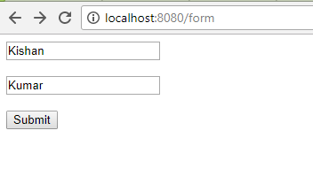

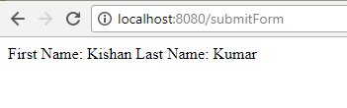

* **Use @ModelAttribute annotation to add Heading "Spring MVC Demo" in every model.**

@Controller  
**public class** StudentController{  
@ModelAttribute  
 **public void** defaultAction(Model model){  
  
 model.addAttribute(**"message"**,**"Spring MVC Demo"**);  
  
 }  
 @RequestMapping(**"/index"**)  
 **public** ModelAndView callIndexJsp(){  
  
 ModelAndView modelAndView = **new** ModelAndView(**"index"**);  
 **return** modelAndView;  
 }  
  
}

